EV Sales Insights by Maker in India

# Project Description: This Power BI dashboard provides a comprehensive analysis of electric vehicle (EV) sales across India, focusing on manufacturers (makers) and vehicle categories (2-Wheelers and 4-Wheelers). It uses monthly sales data to uncover market trends, identify top-performing EV makers, and track adoption patterns over time.

# Key insights include:

# Sales performance by EV maker

# Category-wise distribution (2W vs 4W)

# Monthly and yearly sales trends

# Maker-wise growth patterns

# Market dominance in segments

# PowerBI Dashboard

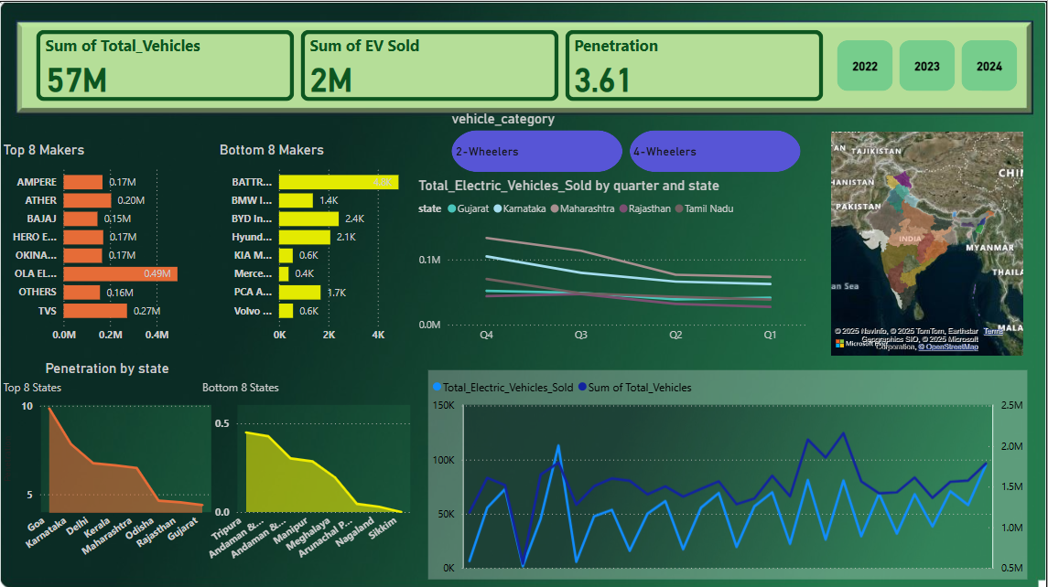

## Dataset Overview

## This project uses three CSV files containing monthly electric vehicle (EV) sales data across India, broken down by state, manufacturer, and date. Below is a description of each file and its structure.

**1. electric_vehicle_sales_by_state.csv**

Contains state-wise monthly sales data for electric and total vehicles, broken down by category.

**Columns:**

* date: The date of the record (e.g., 01-Apr-21)
* state: Name of the state (e.g., Sikkim)
* vehicle_category: Category of the vehicle (2-Wheelers or 4-Wheelers)
* electric_vehicles_sold: Number of EVs sold in that category/state/month
* total_vehicles_sold: Total number of vehicles sold (electric + non-electric)

**2. electric_vehicle_sales_by_makers.csv**

Contains EV sales data by vehicle **maker (brand)** and category over time.

**Columns:**

* date: The date of the record (e.g., 01-May-21)
* vehicle_category: 2-Wheelers or 4-Wheelers
* maker: Manufacturer or brand (e.g., OLA ELECTRIC, OKAYA EV)
* electric_vehicles_sold: Number of EVs sold by that maker in that category/month

**3. dim_date.csv**

A date dimension table useful for time-series analysis.

**Columns:**

* date: The date entry (e.g., 01-May-21)
* fiscal_year: Indian fiscal year (e.g., 2022)
* quarter: Fiscal quarter (Q1, Q2, etc.)

## **Strategic Analysis Objectives**

1. **Which EV maker has sold the most vehicles overall?**
2. **How have EV sales changed over time (monthly or yearly)?**
3. **Which vehicle category (2-Wheeler or 4-Wheeler) has higher EV sales?**
4. **What is the sales trend for a specific EV maker (e.g., Ola Electric)?**
5. **Who are the top 5 EV makers by total sales?**
6. **What were the EV sales in a specific month or year?**
7. **Which EV maker dominates the 2-Wheeler or 4-Wheeler segment?**

# 📊 List of Visualization Tools Used in the Dashboard

| **Visualization Type** | **Purpose / Significance** |
| --- | --- |
| **KPI Cards** | Display key summary metrics: Total Vehicles (57M), EV Sold (2M), and Penetration (3.61%) |
| **Bar Charts** (Top/Bottom Makers) | Show comparison of EV sales among top and bottom 8 manufacturers |
| **Line Chart** (Total Sales Trend) | Track monthly trend of Total vs Electric Vehicle sales over time |
| **Map Visualization** | Geographical distribution of EV sales across Indian states |
| **Line Chart by Quarter & State** | Compare EV sales across major states by quarter, showing trends geographically |
| **Area/Line Charts (Penetration by State)** | Identify states with highest and lowest EV penetration |
| **Slicers (Year, Category)** | Allow filtering data by fiscal year (2022–2024) and vehicle category (2W/4W) |